THE SITUATION OF THE LGBTI+ COMMUNITY AT TURKİSH UNIVERSITIES
THE EXAMPLE OF THE MIDDLE EAST TECHNİCAL UNIVERSITY

Özgür Gür

“Europe has seen xenophobia and LGBT as an internal tension, and they try to transfer it to Turkey”, Minister Süleyman Soylu, August 2019

Introduction
At the moment, parts of Turkish youth belonging to LGBTI+, Kurdish minority or opponents of the rulling AKP party are intimidated and marginalized. Any public criticism or sign of protest increasingly leads to prosecutions and serious punishments. Over 100,000 students are currently on trial and 70,000 students have been detained. Any political activity at universities including student demonsration is banned. The direct elections of the university rector have been abolished. Students who dare to protest are evicted from state dormitories and their scholarships are cut without questioning.
The youth in Turkey has always been trivialized and it struggled to achieve the freedom of speech and its right to education, but within the last years the situation has become more difficult for students. The first changes in the government’s youth policy came in response to the Gezi Park events in 2013. Gezi begun as a reaction against the increasing pressure over freedom on speech, assembly, press and secularism.The sharpest turn, however, came after the attemped military coup in July 15 in 2016, which was an attempt to overthrow the governing regime.
The situation is the worst for students who are active on issues of gender equality and LGBTI+ rights. In the past, the majority of LGBTI+ events took place without much attention and were generally ignored in Turkey. After the Gezi events, however, LGBTI+ activists joined forces with the democratic opposition. The results were visible at the İstanbul Pride which took place after the Gezi Events; tens of thousands of people attended. Authorities’ attention led, in 2015 for the first time, to the event being banned. Police used disproportionate force to disperse the parade. Ever since, the state started to consider the LGBTI+ movement as a serious threat and started to prohibit and attack the LGBTI+ movement routinely.
On 9th November 2017, Turkish president, Recep Tayyip Erdogan, delivered a speech to neighborhood muhtars. He said that the oldest Turkish political party “CHP imposes a gay quota for the election to be made at District Municipality Neighborhood Committees. May Allah lead them to the right path”. Nine days later the Governor of Ankara introduced an “indefinite ban” for all kinds of “LGBTİ+” events. The governor based his decision on the – at the time – ongoing state of emergency, despite the fact that there was no basis for an indefinite ban within the state of emergency law. This was followed with other (mostly individual and not indefinite) bans on LGBTI+ events in cities across Turkey.
Most recently, on 21 June 2019, Turkish Interior Minister Suleyman Soylu, gave a speech to TV100 where he said that “now, that group, which includes the LGBTI+ community, is preparing to govern İstanbul. I see that as a threat for both İstanbul and Turkey.”” Soylu claimed LGBTI+ persons are preparing for the election of İstanbul municipality as if it were a political party and he considered this as a threat. To understand what this means for the LGBTI+ community in Turkey this paper takes a closer look at the events that took place at the Middle East Technical University (METU) in Ankara, at which the top 0.1 percent of eight million Turkish students study. This paper tells their story and calls for a much clearer support and action from the EU and other international actors.
Welcome to METU
The Middle East Technical University (METU) in Ankara is a public technical university. It was established in 1956 and ever since it has been attracting the most successful and the most talented students in Turkey. With a strong focus on research and education in engineering and natural sciences, in 1970s and beyond, METU grew into a place where students fought for freedom in Turkey.
Since the turn of the century, METU was a place where students regularly organized protests. In 2012, when then prime minister Erdoğan visited the METU, he was escorted with thousands of police officers. Students responded with a protest movement later known as the METU Is Rising (ODTÜ Ayakta).The ODTÜ Ayakta is considered as a one of the starting point of the Gezi Events in 2013. As a witness from that time, Tarih Direniyor, explained the link:
“Actually all of [the protests] belong to a process. The protests which we are calling ODTÜ Ayakta were neither a day nor a week. Neither did it start on the 18th December nor did it finish on the 27th of December. Gezi also neither started on the 31st of May nor did it last 20 days. All of them were triggering events to each other.” (Bürkev, 2016)
In 1996, the first LGBTI+ university based society in Turkey, the METU LGBTI+ Solidarity, was founded. Their stated aim was “to secure gender equality, eradicate the on-campus LGBTI+ discrimination, and ensure that the university is a safe space for LGBTI+ people.” The fight for being acknowledged and given equal rights began at the time. Since 2011 METU has also hosted a Pride March on Campus – one of the largest campus Pride March in the Eastern Europe and the Middle East.
The call for gender equality went beyond students to include the METU administration as well. The University signed up to the Gender equality sensitive administration and communication (EGERA). In May 2016, “the “Gender Equality Principle and Strategies Document” was adopted and the METU Gender Equality Promotion and Sexual Harassment Prevention Unit was established.” The administration, however, never recognized the METU LGBTI+ Solidarity as an official student club. This was not different than any student club at the universities in the rest of the country. For a long time, repeated applications by the Solidarity to be recognized as an official club were ignored. At some point, it even seemed that the administration was pretending like there were no queer persons at METU campus.
Since 2017, the METU administration has systematically been trying to ban LGBTI+ related activities on the campus, and the last of those attempts was by the METU rector Verşan Kök who’ ordered to “protect” the security at the university during the latest METU Pride March that has resulted with 21 student’s and 1 academics being detanied.
Genderless Toilet
Gender biased toilets are one of the most important problem which trans+ students face with as stated in the report for discrimination towards lgbti+ students at Turkey.
On 15 March 427 signed a petituion for asking genderless toilet from the administration of METU. After 3 months of with any progress students decided protest the attitude of METU. On 22 May students had a protest for gender neutralize all toilets at one building. After protests METU administration had promised to students for 1 toilet to use as genderless. However at June government sided media targeted genderless toilets, activists got threats. Even at main stream media faces of students showed. University administration hasn’t kept the promise and made a statement for declaring refusing the demand on genderless toilet.
The era of bans
On 24 November 2017, the screening of the movie Romeos, a movie about relationship between two men with one of them going through a transition, was banned by Ankara’s Governor. Many institutions and associations published statements against the ban. METU LGBTI+ Solidarity was among them, noting that the ban is against the universal legal principles, as well as noting the administration of METU’s discrimination towards LGBTI+ people. Melike Balkan, an LGBTI+ activist from Solidarity, later explained that “METU LGBTI+ Solidarity also announced that they would organise the event on the campus, which is autonomous, so that the film can be shown.” The university administration, however, had other plans.
According to Balkan, on 25 November 2017, the day of the event the METU administration started to lock the lecture halls to prevent the event, and they even cut the electric power to the university hall. Around sixty people were inside the hall and more than 100 people outside, waiting to watch the film. With the help of the academics, the film could be screened because they gave the power supply from their labs.
At the same time, police were placed at the entrances to the campus. Almost fifty private security guards came to attack the students to stop the event. Balkan recalled that they said that if they do not stop the screening, they would attack them.The students rejected it and didn’t leave the lecture hall. Instead they contacted the related media channels to create a public pressure against the security guards to stop their threats, “because the image of such an attack would be horrible.”
After that event, a march was organized against violence on women and LGBTI+ members. Furthermore, on 18 December 2017, a newly elected Student Council of METU adopted a manifesto for their plans, noting:
“For the principle of supporting gender equality and disability rights at METU; work on rights and find solutions to problems of disabled people, women and LGBTQ+s and any other people who have been marginalized.”
In a response to the organization of the movie screening, the University administration launched a disciplinary investigation against more than 30 people linked to the 'Romeos' movie event and the Pride March. However, with the support of the media, students and academicians, the investigation was closed.
In February 2018 the university administration, in response to the events, had to accept the registration of a student club called Gender Studies Club. In the founding act it was stated that under no circumstances would the Club compromise on its activities regarding LGBTI+ rights.
But as Balkan later explained, the recognition of the club was just one step, since its work was faced with many and constant challenges. One of the members of METU LGBTI+ Solidarity (the name is intentionally hidden by the author):
“The problems we encountered were such, that some of the planned activities like Pride and HIV informing events were unlawfully removed even though we had previously provided them with a list of the events that we would hold while applying to be an official club.
Furthermore, after the establishment of this club, we were punished because of the march which took place after the Romeos film event. We can furthermore exemplify the discrimination this club faces with what happened when we attempted to make a workshop named "Transfeminism and Trans Woman In Prisons“ but it wasn't accepted by the rectorate. Therefore, in an attempt to keep the workshop going, we had to change its name to "A Different Look at Gender Based Discrimination: Sex Inequity in Prisons". Clearly, the mention of trans woman and/or LGBTI+ matters wasn't something they wished to have in an event held on campus.”
The METU LGBTI+ Solidarity Club also wanted to organize the 8th METU Pride March on 11 May 2018. But on 4 May 2018, the METU Rectorate sent an email to the all students, academics and workers. In this email, METU LGBTI+ Solidarity was described as an illegal group, the Pride week was banned as a whole, with all of the side events and most significantly the Pride march, also banned. Amnesty International made an urgent call to let the Pride happen, ILGA Europe published an informative notice. On 9 May 2018 student’s clubs declared their position together:
“We, as METU students, want to express our opinions freely and continue our activities. We do not accept the rectorates’ oppression and we stand with the LGBTI+ persons fight for freedom and equal rights in campus which we are also part of. We encourage any and all fellow students to support the rainbow and support METU in all its colors."
Melike Balkan from the Solidarity Club explained what happened:
“As the METU LGBTI+ Solidarity we have tried to connect to the rectorate. However, it wasn’t accepted until just days before the 8th METU Pride March. During the negotiations, the administration offered us to make the Pride event at a lecture hall. As clear as it was to us, how belittling and unacceptable offer that was, it wasn't as clear for the opposing party. We tried to explain why a Pride march cannot take place at a lecture hall. The negotiations continued and with a last minute decision, they accepted a march with the condition that its route be very much restricted. They also accepted to apologize for the emails sent. Just minutes before the Pride they notified us that if we march in any condition police would interfere.”
At the METU Graduation Ceremony, on 6 July 2018, the protest took place against the restriction of freedom of expression and LGBTI+ discrimination. The rector wasn't able to move on with his speech due to the heavy protest noises. During the ceremony, private guards attacked the students who carried some oppositional posters and they ripped the posters after the attack. They attacked the protestors in front of the whole school and their families. In the days that followed, prosecution office started an investigation because of the previous protests and one of the students who is also the president of the student council was detained for a day and released after.
Both for 8th METU Pride March and for METU Graduation Ceremony tens of students were sent to disciplinary office and investigated. It wasn’t limited to METU because also some students of the Ankara University were investigated because they joined the 8th METU Pride March. Banning the events that tooking place at METU were only part of a wider campaign against LGBTI+ and the overall atmosphere created by the authorities.
On 3 February 2019, after the end of the state of emergency, another ban for LGBTI+ events was announced by the Governor of Ankara. On 14 March 2019, Human Rights Watch made a call to the governorship to lift the ban and also noticed the discrimination against LGBTI+ individuals at METU.
In March 2019 the Gender Studies Club wanted to have an event in the campus with the families of LGBTI+ people in Ankara which are called Gökkuşağı Aile Grubu (Rainbow Family Group). METU Rectorate did not allow the event because of the “rainbow” association that was on the banners. The event took place at a café outside of the campus.
In the following month, April 2019, the annual spring festival wasn’t allowed and the rectorate stated that the reason the festival was cancelled was because “the student organization (which is responsible for spring festival) had meetings with LGBT+, Marxist, extreme left wing groups and members of Democratic People’s Party (HDP).”
While the discrimination against the LGBTI+ continued, at the Istanbul Boğaziçi University a Pride March was held with a banner on which it was written “You banned METU Pride March, so we took METU Pride March everywhere!”
On 19 April 2019, the indefinite ban on LGBTI+ events, which was imposed with the state of emergency, was lifted and it was declared in court that even during a state of emergency, events cannot be banned indefinitely.
After the lift of the ban in May 2019, the Solidarity Club wanted to organize the 9th METU Pride March. Taking into account the from the year before, Amnesty International and ILGA Europe made a call for a 9th METU Pride March. Ankara Bar Association also made a call for the 9th METU Pride March. They noted that banning or prohibiting Pride March is against universal human rights. On 6 May 2019, the university sent e-mail to all of the students, academics and workers to announce the ban on the Pride March, as they did the previous year. In the e-mail, they claimed that the ban still continued, despite the opinion of Ankara Bar Association. Furthermore, in the mail it was said that they are in contact with the police headquarters. METU LGBTI+ Solidarity published an announcement to attract public attention on how unlawful the issue was. Two students from the Solidarity initiated legal proceedings against the university asking for the ban to be lifted. The court has not yet decide on this matter.
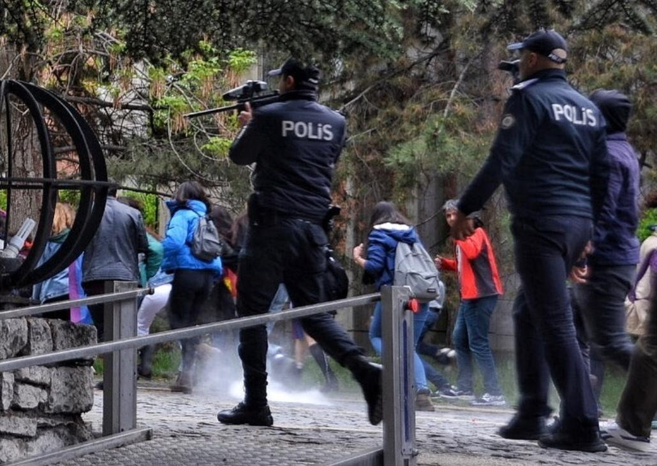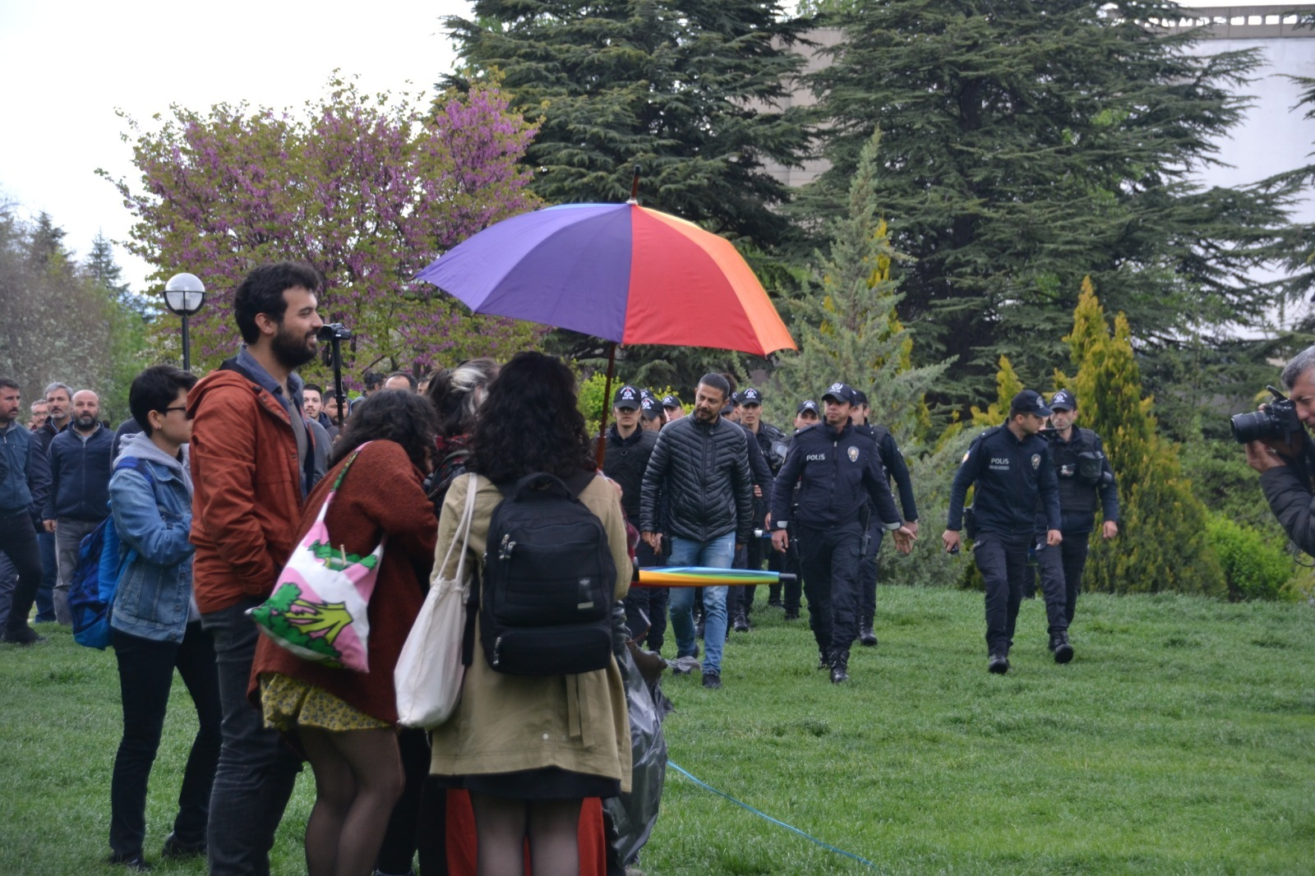
Photo Credit: METU Media Society
The era of violence
On 10 May 2019, the METU LGBTI+ Solidarity announced 17:30 as the time of gathering for 9th METU Pride March. As Melike Irem Balkan explained:
“Because it was a rainy day, we opened a sunshade, and hung a rainbow flag at 14h. After a while, more than 50 police and their shields blocked us. The lawyers of the LGBTIQ+ Center of Ankara Bar Association and also the observers of Amnesty International were not allowed to enter the campus. Students’ rights were violated. After the lifting of materials, the police stepped back. At 15h, students were sitting around the area and weren’t holding any flags or banners. Despite that fact, hundreds of police officers blocked the students again. Two activist students talked to the police chief and stated that any crowd could sit around that area and the things that were being done to them was unlawful. The police again threatened and said “You two will be taken into custody first, and then the others will be taken no matter what they are doing.” The crowd dispersed. At 16:30, the crowd gathered again around the highest building on campus. The police attacked the crowd without a warning and there was no time to disperse.”
The police used tear gas and plastic bullets towards the crowd. 21 students and 1 academics were taken into custody. After midnight, all of them were released. On that day in Turkey, #ODTÜyeRenkVer (hashtag for the pride) was on trending topics on Twitter all day along. In the statement records of the people who were taken into custody, it was stated that the ban order was not the governer’s, but the rectorate’s.
Human Rights Foundation of Turkey made a call for those who were subjected to the abuses. Many members of the parliament and artists made statements to condemn the police attack. İzmir Bar Association made a statement to condemn the police attack and remark the violation of rights.
After that violent police attack, the students summoned all the students in the university to boycott the rectorate on 14 May, by not attending the classes or any work and they stated that: “while there is a presence of violence, oppression and hate, no classes can be done.”
Workers of METU Union condemned the police attack and gave support for the boycott. 333 people including 30 retired professors signed a notice to condemn the police attack towards the students and colleagues and stated:
“METU which has long established traditions, we remind university directors of their responsibilities, we demand first self–criticism and following the necessary steps from them.”
A day earlier, on 13 May, thousands of people attended the protests in front of the rectorate building. On 14 May, students didn’t attend classes. The protests kept going on all day. Academics attended the boycott as well and met with the students in front of the rectorate. Students have also made a call to METU President Verşan Kök to resign from office.
On 30 June, just hours before the METU Graduation Ceremony, at 04:30 in the morning, anti-terrorism police entered the houses of 6 students and 4 of them were taken under custody. It was only at 15:00h that the reason why the students were taken into custody was announced by the police. The police claimed that they were going to conduct a terrorist attack during the graduation ceremony. In the interrogation, they were questioned about their intentions to repeat the Gezi Events and the protests that were going on at METU. After the graduation ceremony, all of the students were released.
On 2 July, the Police Department of Ankara sent a note to Credit and Dormitories Institution with the names of the students who got under custody at the 9th Pride March. This resulted with cutting of the scholarships of those students. On 5 and 12 July, the two members of the parliament questioned these actions.
On 2 August, a trial began for the 9th Pride March, with 18 students and 1 academic being charged with violating the law of meetings and demonstration. The prosecution office claimed that police used proportional force. Also one student had been charged with insulting the officer. On 7 August, Front Line Defenders stated that: “METU must stop violating rights of students defending LGBTI+ rights.” On 9 August Civil Right Defenders published a statement. CRD noticed that harassment of Turkey’s LGBTI+ community continues. On 12 August Amnesty International made a call to drop charges against pride parade participants at the university.
What can be done?
Since the beginning of unlawful attitude toward LGBTI+ members at universities, the EU has not made a strong statement. The EU should stand up and be clear that bans are unlawful and against universal human rights.
The EU Delegation in Ankara should follow closely and react to all legal processes related to bans, as well as protests at universities. The EU hould insist on Pride Marches being allowed and with the necessary protection.
Universities get resources and fundings from the EU and related bodies, so these should be conditioned with full freedom for LGBTI+ people. The current behavior should not be tolerated and the universities having such attitude should not benefit from EU fundings.
According to the constitution of Turkey, all universities are under control of the Council of Higher Education (YÖK). In 2015, YÖK prepared a policy paper on gender. This paper was based on the Convention on the Elimination of All Forms of Discrimination Against Women (CEDAW) and the İstanbul Convention (Council of Europe Convention on Preventing and Combating Violence Against Women and Domestic Violence). The Istanbul Convention prescribes that the standards for fighting discrimination based on sexual orientation and gender identity must be met. This is how the YÖK’s paper provided the basis for gender studies as an academic discipline. However, on 20 February 2019, YÖK announced that they would cancel the gender equality paper. The YÖK’s gender equality paper should be followed and encouraged not to be lifted, and should be improved instead.
Funding for LGBTI+ activist organizations should be increased and improved. Especially those that have no official base, such as university LGBTI+ organizations, should be supported.

Minister Süleyman Soylu targeted LGBTI+s again! (2019, August 22). Retrieved from: https://www.kaosgl.org/page.php?id=28660
70 bin öğrenci hapiste. (2017, October). Retrieved from: http://www.cumhuriyet.com.tr/haber/egitim/856384/70_bin_ogrenci_hapiste.html
Rector elections in Turkey lifted under latest decree. (2016, November). Retrieved from: https://www.birgun.net/haber/rector-elections-in-turkey-lifted-under-latest-decree-133554
Emniyetten KYK yurtlarına 'gizli talimat': Haklarında kesinleşmiş mahkeme kararı bulunmayan öğrencilerin yurttan atılması istendi. (2019, May 26). Retrieved from: https://t24.com.tr/haber/emniyetten-kyk-yurtlarina-gizli-talimat-haklarinda-kesinlesmis-mahkeme-karari-bulunmayan-ogrencilerin-yurttan-atilmasi-istendi,823053
Erdoğan Criticizes LGBTI Quota at Municipalities. (2017, November). Retrieved from: https://bianet.org/english/politics/191397-erdogan-criticizes-lgbti-quota-at-municipalities
Yasaklama Kararına İlişkin Basın Duyurusu (2017, 19 November). Retrieved from: http://www.ankara.gov.tr/yasaklama-kararina-iliskin-basin-duyurusu-19112017
Süleyman Soylu: LGBT’yi Türkiye için bir tehdit olarak görüyorum . (2019, 21 June). https://indigodergisi.com/2019/06/suleyman-soylu-lgbt-yi-turkiye-icin-bir-tehdit-olarak-goruyorum/
Bürkev Yalçın. (2016). ODTÜ tarih direniyor. Kadıköy, Istanbul: Nota Bene Yayınları.
https://www.frontlinedefenders.org/en/organization/metu-lgbti-solidarity
EGERA Charter for gender sensitive governance in research – higher education institutions . retrieved from https://citob.metu.edu.tr/system/files/egeracharterforgendersensitivegovernance.pdf - https://citob.metu.edu.tr/system/files/egerachartergendersensitivecommunication.pdf
http://sp.metu.edu.tr/system/files/odtu_sp_2018_02_08.pdf
Korkmaz, M. (2019). 2016-2017 Yilinda Türki̇ye’Deki̇ Üni̇versi̇telerde Lgbt Öğrenci̇lere Yöneli̇k Gerçekleşti̇ri̇len Ayrimciliklar. Ankara: Şen Matbaa.
Facebook. (n.d.). Retrieved from https://www.facebook.com/events/1131158266990746/.
www.ahaber.com.tr. (2017, June 23). Erkan Tan: ODTÜ kapatılsın yerine ise... Retrieved from https://www.ahaber.com.tr/video/gundem-videolari/erkan-tan-odtu-kapatilsin-yerine-ise.
Aa. (2017, June 22). ODTÜ'den 'cinsiyetsiz tuvalet' açıklaması. Retrieved from http://www.hurriyet.com.tr/gundem/odtuden-cinsiyetsiz-tuvalet-aciklamasi-40498941.
ODTÜ’de cinsiyetçi ve homofobik yönetime karşı yürüyüş. (2017, November.) https://www.evrensel.net/haber/338872/odtude-cinsiyetci-ve-homofobik-yonetime-karsi-yuruyus
ODTÜ’de cinsiyetçi ve homofobik yönetime karşı yürüyüş. (2017, November.) https://www.evrensel.net/haber/338872/odtude-cinsiyetci-ve-homofobik-yonetime-karsi-yuruyus
ODTÜ Öğrenci Temsilcileri Konseyi 2017 – 2018 Plan Bildirgesi https://www.facebook.com/odtuotk/photos/a.1909109659319980/2077179692512975/?type=3&theater
Af Örgütü’nden ODTÜ Onur Yürüyüşü İçin Acil Eylem. (2018, Mayıs). https://bianet.org/bianet/lgbti/196877-af-orgutu-nden-engellenen-odtu-onur-yuruyusu-icin-acil-eylem
‘Biggest Campus-Centered Pride Parade of Middle East and Balkans’ by METU Students. (2018, May 10) http://bianet.org/english/society/197012-biggest-campus-centered-pride-parade-of-middle-east-and-balkans-by-metu-students
ODTÜ mezuniyetinde gökkuşağı bayrağına saldırı. (2018, July 6). Retrieved from: http://kaosgl.org/sayfa.php?id=26223
Rainbow flag in METU graduation ceremony is under investigation. (2018, September). https://kaosgl.org/page.php?id=26641
“A new ban from Ankara Governorship on LGBTI events!”. (2018, October 9). http://kaosgl.org/page.php?id=26759
“HRW: End Ankara Ban on LGBTI Events”. (2019, February 14). https://kaosgl.org/page.php?id=27591
Ban at METU due to “the relation of rainbow-LGBT”. (2019, March 27). https://kaosgl.org/page.php?id=27938
“An alternative family is possible!”.(2019, March 27). https://kaosgl.org/page.php?id=27939
Discriminative ‘statement’ from METU Rectorate. (2019, April 16). https://kaosgl.org/page.php?id=28073
7th Pride Parade Held in Boğaziçi University. (2019, May 19). https://bianet.org/english/lgbti/207643-7th-pride-parade-held-in-bogazici-university
Court Lifts LGBTI+ Event Ban in Ankara. (2019, April 19). https://m.bianet.org/english/lgbti/207665-court-lifts-lgbti-event-ban-in-ankara
Turkey: Banned Pride march must be allowed to take place. (2019, May 7). https://www.amnesty.org/en/latest/news/2019/05/turkey-banned-pride-march-must-be-allowed-to-take-place/
Basın Açıklaması. (2019, May 9). http://www.ankarabarosu.org.tr/HaberDuyuru.aspx?BASIN_ACIKLAMASI&=2964
ODTÜ’deki Onur Yürüyüşü Yasağı Yargıya Taşınıyor. (2019, Mayıs 6) https://m.bianet.org/bianet/lgbti/208189-odtu-deki-onur-yuruyusu-yasagi-yargiya-tasiniyor
Nefrete İnat Yaşasın Hayat. (2019, May 11). https://www.izmirbarosu.org.tr/HaberDetay/1582/nefrete-inat-yasasin-hayat
ODTÜ’lülerden Polis Şiddetine Karşı Boykot Çağrısı. (2019, Mayıs 13). https://bianet.org/bianet/lgbti/208436-odtu-lulerden-polis-siddetine-karsi-boykot-cagrisi
“Aşağıda ismi bulunan ODTÜ Öğretim Elemanları'nın 10 Mayıs 2019 Cuma günü ODTÜ'de yaşananlara ilişkin açıklaması:” (n.d.) http://www.odtusavunulmalidir.com
METU Students Boycott Classes to Protest Violance in Pride Parade.(2019, May 14) https://bianet.org/english/women/208489-metu-students-boycott-classes-to-protest-police-violence-in-pride-parade
METU Students Detained Over an Informer’s E mail, Miss Graduation Ceremony. (2019, June 30) https://bianet.org/english/human-rights/209962-metu-students-detained-over-an-informer-s-email-miss-graduation-ceremony
Students Stripped of Scholarships for Attending LGBTI+ Parade. (2019, July 2). https://bianet.org/english/lgbti/210013-students-stripped-of-scholarships-for-attending-lgbti-parade
KYK’nın ODTÜ Onur Yürüyüşü’nde gözaltına alınan öğrencilerin kredilerini kesmesi meclis gündeminde. https://kaosgl.org/sayfa.php?id=28480- https://kaosgl.org/sayfa.php?id=28522
Lawsuit Against 19 METU Students for Joining Pride Parade. (2019, August 8) https://bianet.org/english/lgbti/211477-lawsuit-against-19-metu-students-for-joining-pride-parade
METU Must stop violating rights of students defending lgbti+ rights. https://www.frontlinedefenders.org/en/case/metu-university-rectorate-must-stop-violating-right-peaceful-assembly-students-defending-lgbti
Harassment of Turkey’s LGBTI+ community continues. (2019, August 9). https://crd.org/2019/08/09/harassment-of-turkeys-lgbti-community-continues/
YÖK’ün Kaldırdığı Toplumsal Cinsiyet Eşitliği Tutum Belgesi. (2019, February). https://m.bianet.org/bianet/toplumsal-cinsiyet/205680-yok-un-kaldirdigi-toplumsal-cinsiyet-esitligi-tutum-belgesi

